PIZZA SALES SQL QUERIES

# A. KPI’s

## 1. Total Revenue:

SELECT SUM(total_price) AS TOTAL_REVENUE FROM pizza_sales;

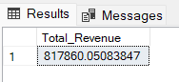

## 2. Average Order Value

SELECT CAST(SUM(total_price) / COUNT(DISTINCT order_id) AS DECIMAL(10,2)) AS AVG_ORDER_VALUE

FROM pizza_sales;

## 38.31

## 3. Total Pizzas Sold

SELECT SUM(quantity) AS Total_Quantity FROM pizza_sales;

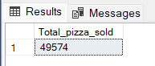

## 4. Total Orders

SELECT COUNT(DISTINCT order_id) AS Total_Orders FROM pizza_sales;

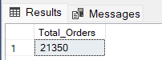

## 5. Average Pizzas Per Order

SELECT CAST (CAST(SUM(quantity) AS DECIMAL(10,2)) / CAST(COUNT(DISTINCT order_id) AS DECIMAL(10,2))

AS DECIMAL(10,2))AS Avg_Pizza_Per_Order

FROM pizza_sales;

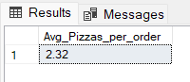

## B. Daily Trend for Total Orders

--Daily Trend

SELECT DATENAME(DW,order_date) AS Order_Day, COUNT(DISTINCT order_id) AS Total_Orders

FROM pizza_sales

GROUP BY DATENAME(DW,order_date);

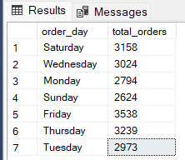

## C. Hourly Trend for Orders

--Hourly Trend

SELECT DATEPART(HOUR, order_time) AS Order_Hours,

COUNT ( DISTINCT order_id) AS Total_Orders

FROM pizza_sales

GROUP BY DATEPART(HOUR,order_time)

ORDER BY DATEPART(HOUR,order_time);

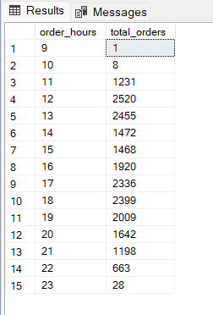

## D. % of Sales by Pizza Category

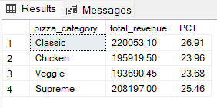

## E. % of Sales by Pizza Size

--Percentage Of Sales By Pizza Size

SELECT pizza_size,CAST(SUM(total_price) AS DECIMAL(10,2)) AS Total_Sales,CAST(SUM(total_price)*100/

(SELECT SUM(total_price)FROM pizza_sales ) AS DECIMAL(10,2)) AS PCT

FROM pizza_sales

GROUP BY pizza_size

ORDER BY pizza_size;

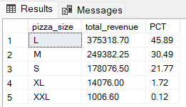

## F. Total Pizzas Sold by Pizza Category

SELECT pizza_category, SUM(quantity) AS Pizza_Sold

FROM pizza_sales

GROUP BY pizza_category

ORDER BY Pizza_Sold DESC;

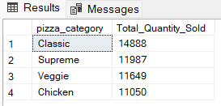

## G. Top 5 Best Sellers by Total Pizzas Sold

SELECT TOP 5 pizza_name, SUM(quantity) AS Total_Pizza_Sold

FROM pizza_sales

GROUP BY pizza_name

ORDER BY Total_Pizza_Sold DESC;

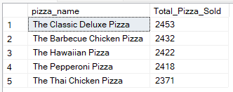

## H. Bottom 5 Best Sellers by Total Pizzas Sold

SELECT TOP 5 pizza_name, SUM(quantity) AS Total_Pizza_Sold

FROM pizza_sales

GROUP BY pizza_name

ORDER BY Total_Pizza_Sold;

